Little Stock Study

stock_key = "ooA1BDEnla5owTATGDfKAuIi6puKOitC"

Goal: Creating MACD and Bollinger Band Charts for trading purposes

Resources:

<https://www.investopedia.com/terms/e/ema.asp>

What Is an Exponential Moving Average (EMA)?

An exponential moving average (EMA) is a type of moving average (MA) that places a greater weight and significance on the most recent data points. The exponential moving average is also referred to as the exponentially weighted moving average. An exponentially weighted moving average reacts more significantly to recent price changes than a simple moving average simple moving average (SMA), which applies an equal weight to all observations in the period.

* Traders often use several different EMA lengths, such as 10-day, 50-day, and 200-day moving averages.

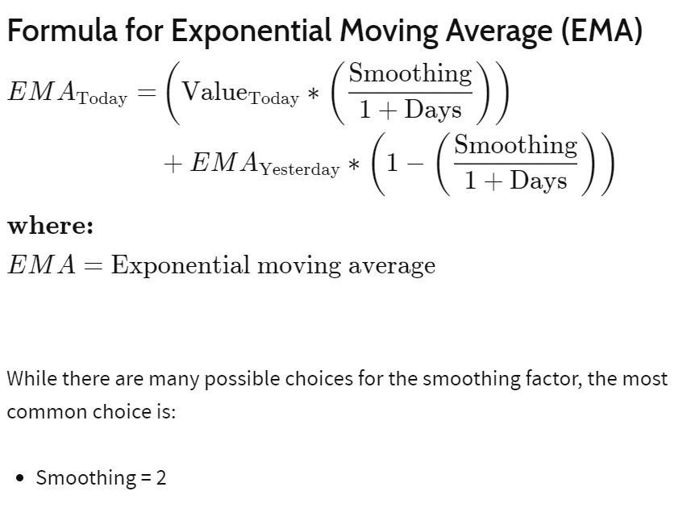

<https://school.stockcharts.com/doku.php?id=technical_indicators:moving_average_convergence_divergence_macd#:~:text=The%20signal%20line%20is%20a,crosses%20below%20the%20signal%20line>.

<https://www.investopedia.com/terms/m/macd.asp#:~:text=MACD%20is%20best%20used%20with,below%20it%20(to%20sell)>.

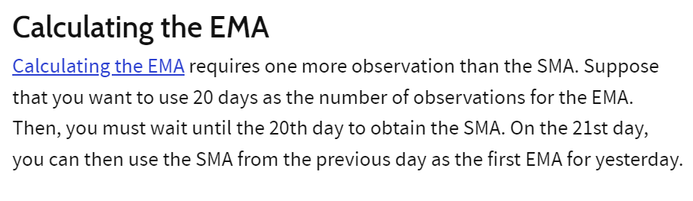

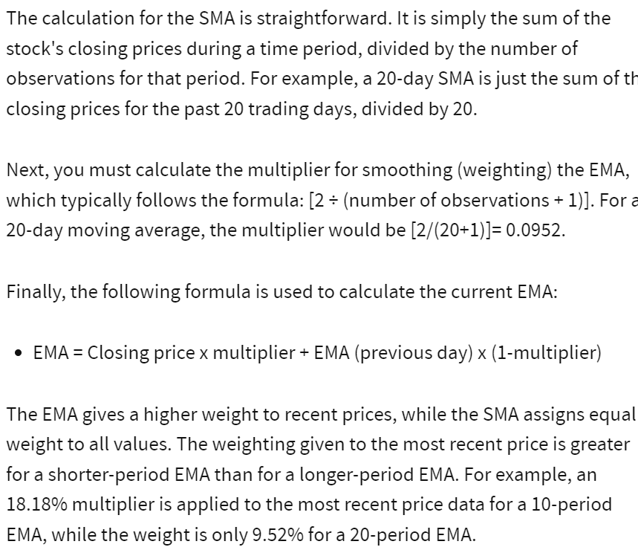

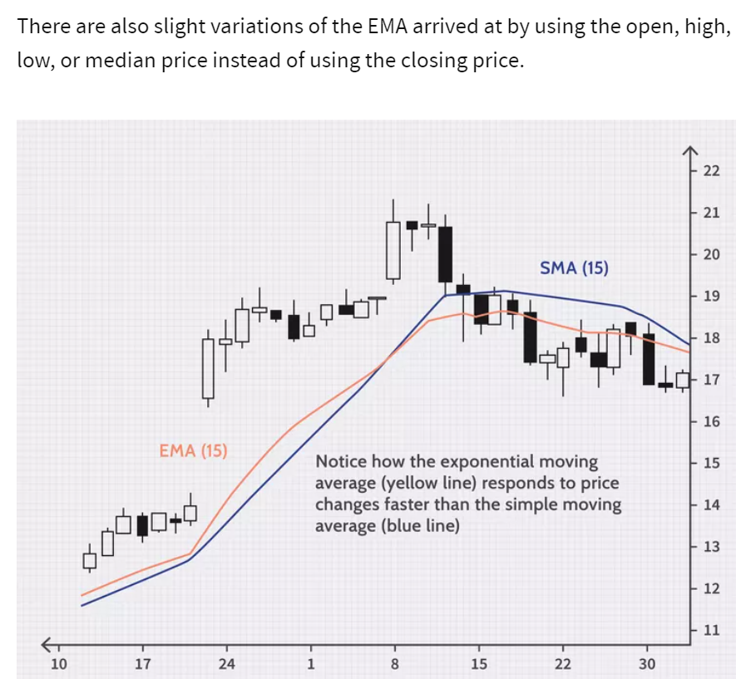

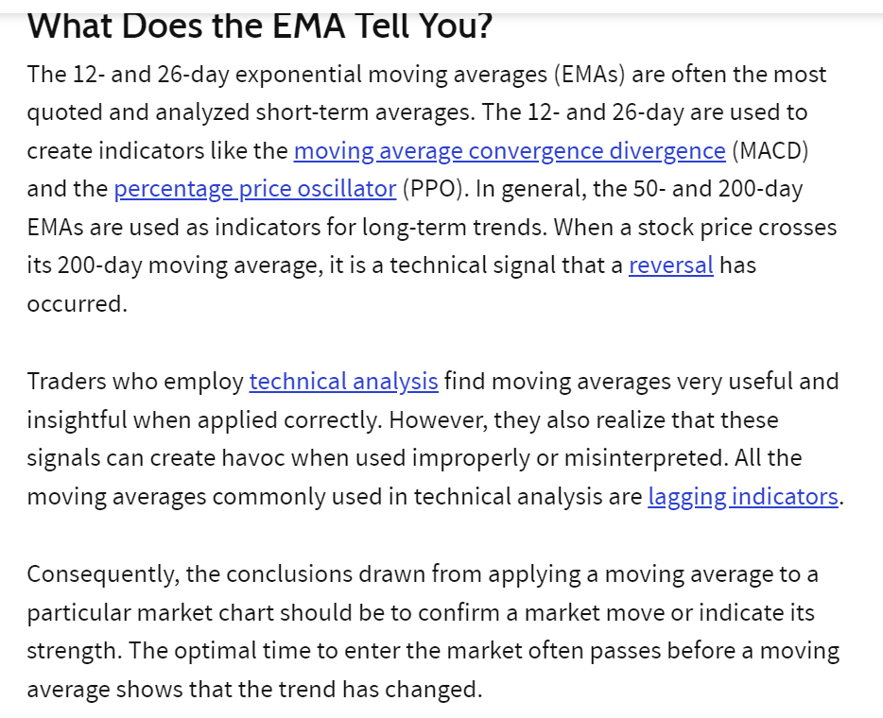

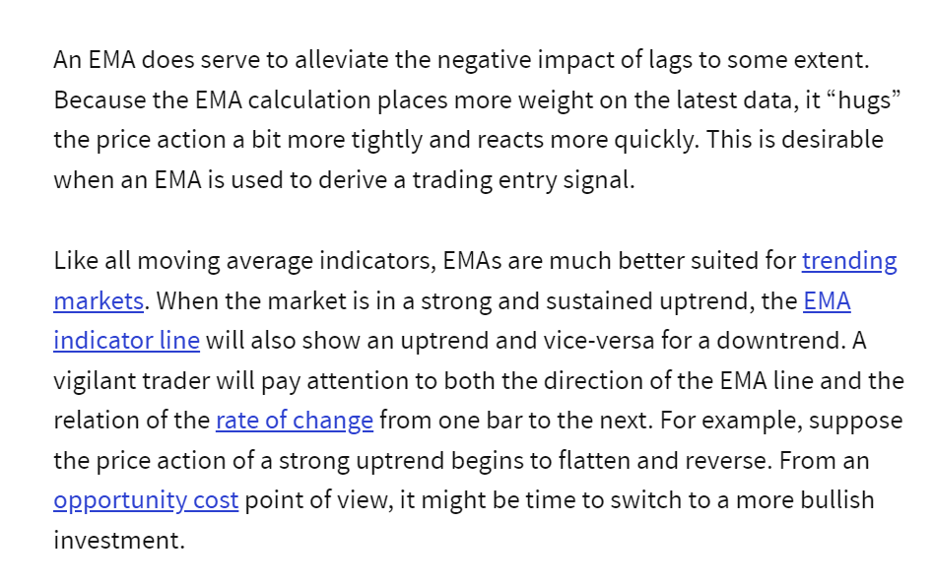

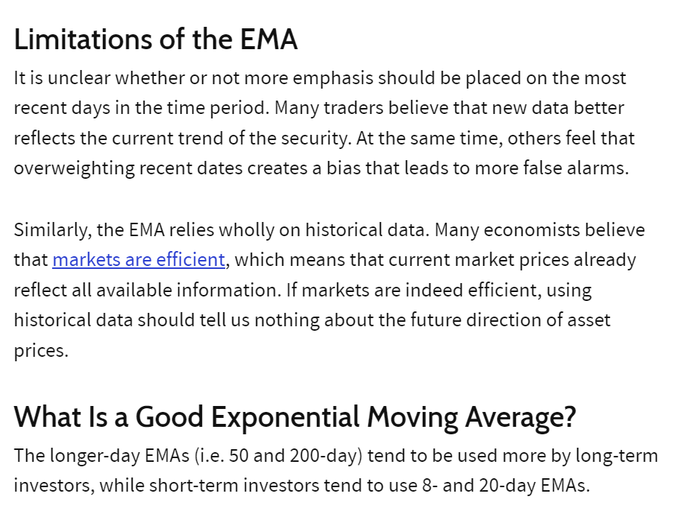

Table Needs:

Using <https://app.quickdatabasediagrams.com/#/>

I capture these tables.

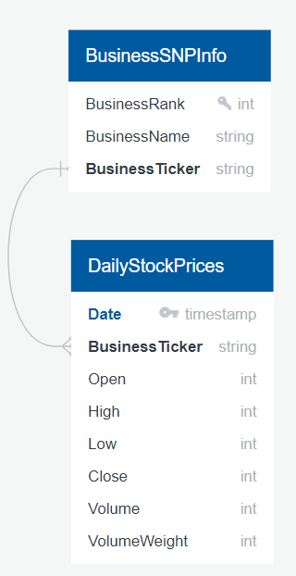

BusinessSNPInfo

--------------

BusinessRank int UNIQUE

BusinessName string

BusinessTicker string

DailyStockPrices

----------------

Date timestamp PK

BusinessTicker string FK >- BusinessSNPInfo.BusinessTicker

Open int

High int

Low int

Close int

Volume int

VolumeWeight int

# the formula for EMA is this:

# For days = n take n day's prices and divide them by n. This gives you the SMA (Simple Moving Average) - THIS IS THE FIRST EMA FOR YESTERDAY.

# EMA(today) = (value(today) * (smoothing/(1+days)) + EMA(yesterday) * (1 - (smothing/(1+days)))

# Example: Say you want the EMA for days = 5 with a smoothing factor of 2

# and the closing price of stock ABC is {(20240105,87.00), (20240106,90.00), (20240107,91.00), (20240108,88.00), (20240109,92.00)} <-- concern dates are needed for visualization!

# SMA = (87 + 90 + 91 + 88 + 92)/5 = 89.6 => EMA(yesterday)

# Assign day 2 to day 1, day 3 to day 2, day 4 to day 3, day 5 to day 4. (you have to do this before reading the next closing price.)

# Read the next record. (closing price is (20240110,90.00)

# Assign next record's closing price to day 5.

# Calculate EMA(today) = (90 * (2/6) + 89.6 * (1 - (2/6))) = 89.73

# move date and EMA(today) to tuple (immutable!!!). EMATuple = ((date,EMA)) t[0] = ((20240110,89.73))

# add 1 to the TupleIndex

# Assign day 2 to day 1, day 3 to day 2, day 4 to day 3, day 5 to day 4. (you have to do this before reading the next closing price.)